i

اطلب هذه الرسالة باللغة العربية عن طريق الاتصال ب engagement@tfw.wales
Weydiiso warqaddan oo ku qoran af Soomaali adoo la xiriiraya engagement@tfw.wales
engagement@tfw.wales ڈاٹ ویلز سے رابطہ کرکے اردو میں اس خط کی درخواست کریں

Gorffennaf 2024

Annwyl Gymydog,
Cyf: Metro De Cymru – Gwaith pentyrru llinell y Bae

Mae Trafnidiaeth Cymru yn darparu'r Metro, dyma fydd yr uwchraddiad mwyaf i system trafnidiaeth gyhoeddus De-ddwyrain Cymru ers cenhedlaeth. Dros y blynyddoedd nesaf bydd gennym lawer iawn o waith adeiladu, peirianneg a seilwaith i'w wneud i uwchraddio ein rhwydwaith rheilffyrdd fel ei fod yn barod ar gyfer y Metro. I ddechrau, bydd hyn yn cynnwys gwaith ar reilffyrdd Aberdâr, Coryton, Merthyr Tudful, Rhymni a Threherbert, llinellau y Dinas a’r Bae, sy’n cael eu galw yn Llinellau Craidd y Cymoedd.

Rydyn ni’n ysgrifennu atoch i roi gwybod i chi am weithgaredd arbennig o swnllyd yn ystod y nos a fydd yn digwydd yn eich ardal chi cyn bo hir.

Gwaith gosod seilbyst sydd ar y gweill
Fel rhan o Metro De Cymru, byddwn yn trydaneiddio llinell y Bae. Bydd hyn yn ein galluogi i wella amlder y gwasanaeth a chyflwyno trenau trydan newydd sbon.
I bweru'r trenau newydd, mae angen i ni osod Offer Llinell Uwchben (OLE), sy'n cynnwys y pyst dur a'r gwifrau sy'n rhedeg uwchben y trên, gan gyflenwi trydan iddo. Mae'r gwifrau wedi'u gosod ar byst dur sydd rhwng 20 a 65 metr ar hyd y llwybr.
I osod offer llinellau uwchben (OLE), rhaid i ni gynnal proses adeiladu yn gyntaf o’r enw gosod seilbyst. Bydd hyn yn creu’r sylfeini ar gyfer pob un o’r pyst dur sy’n cario’r gwifrau i bweru’r trenau newydd. Mae gosod seilbyst yn gallu bod yn waith swnllyd gan ei fod yn cael ei wneud gan beiriannau trwm, a bydd lefelau’r sŵn yn dibynnu ar y pellter o leoliad y gwaith a thopograffi lleol. Byddwn yn gwneud ein gorau glas i leihau unrhyw sŵn diangen, fel gweiddi, a chwblhau'r gwaith mor gyflym â phosibl.

Gan ddibynnu ar amodau’r tir, mae gosod seilbost arferol yn gallu cymryd rhwng ugain i chwedeg muned i osod pob sylfaen. Mae gosod seilbyst drwy daro’n aml yn cael ei wneud mewn un sesiwn er mwyn i’n peirianwyr allu symud ymlaen i’r lleoliad nesaf felly ni ddylai’r sŵn bara’n rhy hir, ond mae gosod seilbyst drwy dyllu’n galw am ail ymweliad i gwblhau’r gwaith drwy dywallt concrid i mewn.

Gallwch ddarllen rhagor am ein gwaith gosod seilbyst yn trc.cymru/cy/gosod-seilbyst.
Gallwch chi ddarllen rhagor am offer llinellau uwchben yn trc.cymru/cy/trydaneiddio-llinellau-uwchben.

Pryd fyddwn ni’n gweithio

Byddwn yn gweithio rhwng 23:00 a 05:00 o ddydd Llun 8 Gorffennaf i ddydd Iau 11 Gorffennaf 2024.
Yn ystod y cyfnod hwn, bydd ein timau'n gweithio ddydd a nos i wneud gwaith pentyrru ar hyd llinell y Bae, ac yn gosod pyst dur ar y sylfeini gorffenedig a fydd yn cario'r gwifrau uwchben.
Ar ôl cwblhau pob sylfaen, byddwn wedyn yn dychwelyd yn ddiweddarach i osod yr offer OLE sy'n weddill. Bydd y gwaith hwn yn parhau gyda'r nos yn ystod yr wythnosau nesaf, ond ni ddisgwylir iddo fod mor aflonyddgar â'r gwaith pyst.
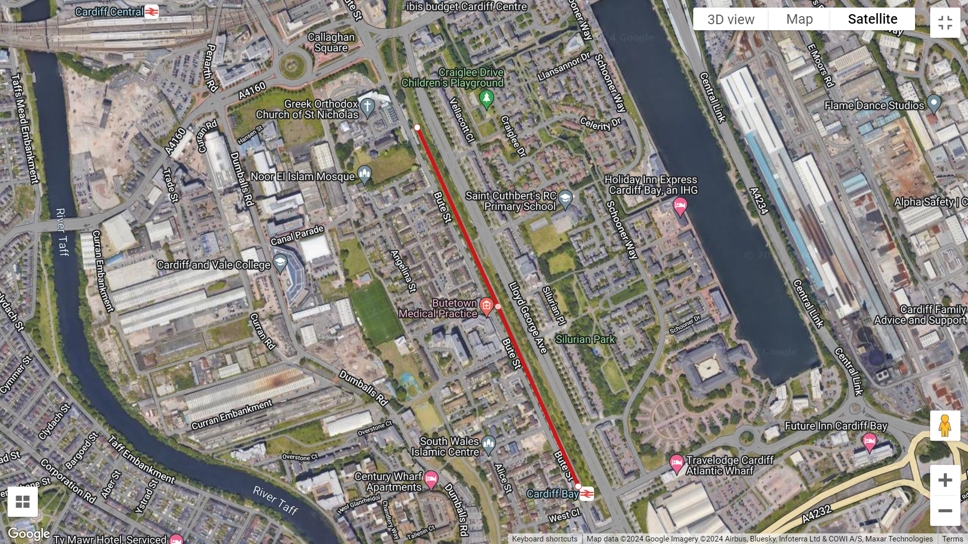
Mae Llywodraeth Cymru a TrC wedi ymrwymo i raglen uchelgeisiol o welliannau Metro a elwir yn Drawsnewidiad Llinellau Craidd y Cymoedd (CVL). Mae'r prosiect trawsnewid hwn wedi'i ariannu'n rhannol gan Gronfa Datblygu Rhanbarthol Ewrop.

Mwy o wybodaeth

Dyma'r dolenni er mwyn cael mynediad at y Cwestiynau Cyffredin mewn ieithoedd eraill:

trc.cymru/cwestiynau-cyffredin-bae-caerdydd
tfw.wales/cardiff-bay-line-faq-arabic
tfw.wales/cardiff-bay-line-faq-somali
tfw.wales/cardiff-bay-line-faq-urdu

Rhagor o wybodaeth

Mae ein tîm ar gael 24/7 i ateb eich cwestiynau, felly ffoniwch 033 33 211 202. Gallwch ddefnyddio WhatsApp i gysylltu â ni - 07790 952507 (0700-2000 ddydd Llun i ddydd Gwener, 0800-2000 ddydd Sadwrn a rhwng 1100-2000 ar ddydd Sul).

Yr gywir,Tîm Ymgysylltu Cymunedol, Trafnidiaeth Cymru
اطلب هذه الرسالة باللغة العربية عن طريق الاتصال ب engagement@tfw.wales
Weydiiso warqaddan oo ku qoran af Soomaali adoo la xiriiraya engagement@tfw.wales
engagement@tfw.wales ڈاٹ ویلز سے رابطہ کرکے اردو میں اس خط کی درخواست کریں

October 2024

Dear Neighbour,
Ref: South Wales Metro – Upcoming track and station work

Transport for Wales is delivering Metro, the biggest upgrade to public transport in South-East Wales for a generation. In the next few years, we have a significant amount of construction, engineering, and infrastructure work to do to upgrade our rail network so that it’s ready for Metro. Initially, this will involve work to the Aberdare, Coryton, Merthyr Tydfil, Rhymney, Treherbert, City and Cardiff Bay railway lines, known as the Core Valley Lines.

Upcoming closure of the Cardiff Bay line
As we deliver Metro and increase the number of services travelling into Cardiff from the top of each valley to 4 trains per hour, we need to upgrade the track and signalling at Cardiff Queen Street in preparation for more trains to run through the station.
To undertake these essential upgrades, Cardiff Queen Street Station will be closed, with no rail services stopping at or travelling through the station from Sunday 27 October to Friday 01 November, all day.
Whilst Cardiff Queen Street is closed, we’ll use this opportunity to carry out significant works on the Cardiff Bay line. Due to this, no rail services will travel from Cardiff Bay to Cardiff Queen Street station from Sunday 27 October to Sunday 3 November.
Ticket acceptance will be in place with Cardiff Bus on its Cardiff Bus Baycar number 6 service. We will also operate a partial bus replacement service between Cardiff Central, Cardiff Queen Street and Cardiff Bay during the following hours:
- Sunday 27 October: 20:15 - 23:00
- Monday 28 October to Friday 1 November: 06:30 - 09:15 and 21:15 - 00:00
Track works
From Sunday 27 to Wednesday 30 October, we’ll be carrying out track works along the Cardiff Bay line to realign the existing track to platform 2 at Cardiff Bay station, which has been constructed on the back of the existing platform 1. To ensure the work is completed in time for rail services to resume on Monday 4 November, our teams will work throughout the day and night to complete this work. However, our teams will aim to undertake the nosiest work during the day or evening hours where possible, particularly when we need to tamp the track.
To minimise noise, we’ll deploy acoustic barriers on the Western perimeter of the works area, as well as briefing our teams to ensure they are considerate to those who live close to the railway.
Our teams will continue to use our compound site on Lloyd George Avenue during this work.
Work programme:
Date | Works description
Sunday 27 October | Move equipment onto the track, preparation works at the trackside.
 | Cut and remove the existing rails, moving redundant material to out compound site.
 | Create and compact the new rail bed using ballast (the small stones that lie under the track).
Monday 28 October | Create and compact the new rail bed using ballast.
Compact the ballast.
Re-install the new rail and sleepers.
 | Tamp the track (until 23:00).
Tuesday 29 October | Install the buffer stop at the end of the station.  Weld the rail.
 | Stress rails and clip the rail to the sleepers.
Remove machinery from the track.
Reconnect trackside equipment.
Wednesday 30 October | Minor trackside works.
Snagging works and site clearence.
Remove any remaining equipment.
Cardiff Bay Station: change of platform
When rail services resume on Monday 4 November, all rail services will use platform 2 at Cardiff Bay station. Platform 1 will be closed off to the public as our teams move to upgrade the platform, replacing the temporary platform extension. Access to and from the station will be via Lloyd George Avenue, with the Bute Street entrance closed.

The Welsh Government and TfW are committed to an ambitious programme of Metro improvements known as the Core Valleys Lines (CVL) Transformation. This transformation project has been part-funded by the European Regional Development Fund.

More information

You can access the Bay line FAQs using the links below:

tfw.wales/bayfaqs
tfw.wales/cardiff-bay-line-faq-arabic
tfw.wales/cardiff-bay-line-faq-somali
tfw.wales/cardiff-bay-line-faq-urdu

Contact us

Our team is available to answer your questions 24/7, so please call us on 033 33 211 202 or visit tfw.wales/help-and-contact. You may contact us via WhatsApp on 07790 952507 (0700-2000 on Monday to Friday, 0800-2000 on Saturday, and 1100-2000 on Sunday).

Yours faithfully,
Community Engagement team, Transport for Wales

